# **User Guide**

## Introduction

Python scripts for running the software:



ftmMwMcTransfertoCSV.py: for transferring ftmMwMc.ini configuration file to CSV file format.

ftmMwMdTransfertoCSV.py: for transferring ftmMwMd.ini configuration file to CSV file format.

The following is the steps of using the software, the usage of two scripts are the same, let us use ftmMwMcTransfertoCSV.py as an example for the illustration.

1. Clicking on ftmMwMcTransfertoCSV.py, the user interface shows up.

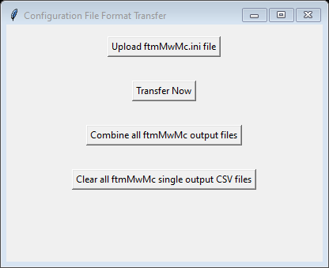

1. 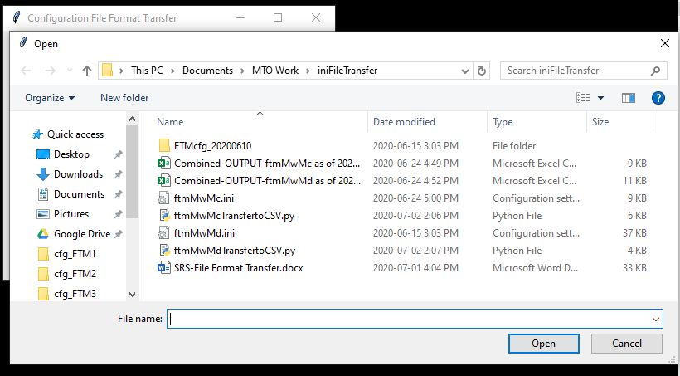To upload the input ftmMwMc.ini file, click on “Upload ftmMwMc.ini file” button. A file dialog page shows up. The default path is set to be the current working directory (where the software script locates).
2. A screenshot of a social media post

   Description automatically generatedSelect the ftmMwMc.ini file, you can select one file each time.
3. Click “Open”, a popup window shows up and tells you the selected file path. Click “OK”.

1. Click “Transfer Now” button to start transfer. The output file is stored in the same folder as the scripts, named as “OUTPUT-ftmMwMc as of *CURRENDATETIME*.csv”.

1. If the script reads the input file and finds format of the configuration file is not expected, an error message shows up. For example, uploaded a ftmMwMd.ini file, ftmMwMcTransfertoCSV.py will not be able to transfer it. The following error message shows up.

1. If the script reads the input file and finds it is not expected input file (not configuration file) or multiple assignments of the same variable, an error message shows up. Please go back and check for the input file.

Input file issue!

Error message if read unexpected input.

1. A screenshot of a cell phone

   Description automatically generatedAfter transferring multiple files to the output CSV-formatted files, you can combine all those single outputted ftmMwMc files by using ‘Combine all ftmMwMc output files’ button. Combined CSV-formatted output is stored in the same directory as the scripts and named as ‘Combined-OUTPUT-ftmMwMc as of *CURRENTDATETIME*.csv’.
2. You can clear all single outputted CSV files by clicking on ‘Clear all ftmMwMc single output CSV files’ button. It is important to clear the directory, otherwise, when combining the files, the previously transferred files will be included as well since they follow the same naming pattern.

Directory cleared after clicking on the “Clear all ftmMwMc single output CSV files” button.